Spring 2023 – Project 8 Strategy Evaluation

Yu-Chang Cheng  
ycheng345@gatech.edu

***Abstract—*** We implemented and explored two different trading learner/ policy. The first was the manual strategy (rule-based) and the other was strategy learner (Random Tree Learner with Bag learner from project 3, with leaf_size =5, bag_size = 100), and two experiments were conducted. The first experiment was to compare their performance with benchmark with both in-sample data and out-of-sample data. The second experiment was to discuss how the impact value may affect the performance of the strategy learner.

# Introduction

In this project, we used stock “JPM” with in-sample period from January 1, 2008 to December 31, 2009 to train our learners and tested it on out-of-sample period from January 1, 2010 to December 31, 2011. We used three different technical indicators with rolling windows equals to 30 days, which are Bollinger Bands Percentage – BBP(30), Price to Simple Moving Average – Price/ SMA(30) and Momentum – MM(30) as our input for both our manual strategy and strategy learner. We will then train and test our strategy learner and the learner gave us the trading order so we could use them to compute the performance. We expected that the during the in-sample period, the strategy learner will perform better than manual strategy and manual strategy will outperform the benchmark. The out-of-sample period is not so certain as the strategy learner may be performing very well at in-sample period but not performing well at out-of-sample period as the market has changed and strategy learner still using the in-sample data. We also experimented on the difference impact value on the strategy learner, we expected that the higher the impact value might cause the strategy learner to perform worse as it will reduce on the trades during the training period and may affect its learning process.

# Intdicator Overview

1. Bollinger Bands Percentage – BBP(30)

The Bollinger Bands Percentage is calculated by BBP = (Stock Price - Lower Bollinger Band) / (Upper Bollinger Band - Lower Bollinger Band) which using the SMA from the past 30 days. The Bollinger Upper band is calculated by adding 2 times the STD to the SMA(30) while the Bollinger Lower band is calculated by subtracting 2 times the STD from

the SMA(30). For the manual strategy, if the BBP(30) > 0.8, we consider as an overbought (short-position), we may sell, if the BBP(30) < 0.2, we consider as an oversold (long-position), we may buy. For the strategy learner, instead setting a rule to determine buy or sell. We used the same BBP(30) as one of the input to train and test our strategy learner directly.

1. Price to Simple Moving Average – Price/ SMA(30)

The Price to Simple Moving Average is calculated by Stock Price / SMA(30) where SMA(30) is calculated by SMA = (P1 + P2 + P3 + ... + P30) / 30 from the past 30 days. For the manual strategy, if the Price/ SMA(30) > 1.2, we consider as an overbought (short-position), we may sell, if the Price/ SMA(30) < 0.8, we consider as an oversold (long-position), we may buy. For the strategy learner, instead setting a rule to determine buy or sell. We used the same SMA(30) as one of the input to train and test our strategy learner directly.

1. Momentum – MM(30)

The momentum is calculated by Momentum(t) = (price[t] / price[t-30]) – 1. It is calculated by comparing the current closing price to the closing price of 30 days ago. The MM(30) refers to the 30-day momentum. For the manual strategy, if MM(30) >5, we consider as an overbought (short-position), we may sell, if the MM(30) <-5, we consider as an oversold (long-position), we may buy. We used the same MM (30) as one of the input to train and test our strategy learner directly.

# Manual strategy

As discussed in previous paragraph, I used three different technical indicators BBP(30), Price/ SMA(30) and MM(30) and set up a rule as above to trigger buy or sell for my manual strategy.

The Bollinger Band Percent (BBP) indicates how close the current price is to the upper or lower Bollinger Band. When the BBP exceeds 0.8, it implies that the stock is closed to the upper Bollinger Band, which may be an overbought scenario, and a possible downturn. On the other hand, when the BBP falls below 0.2, the stock is nearing the lower Bollinger Band, which may be an oversold scenario and a possible upward trend.

The Price to SMA compares the current stock price to its simple moving average (SMA). When Price/ SMA exceed 1.2, it implies that the stock is higher than its average, which may be a possible overbought and When Price/ SMA below 0.8, it implies that the stock is lower than its average, which may be a possible oversold.

The Momentum indicates the rate of change in the stock's price. A positive momentum value above 5 shows that the stock's price is rising and may continue to do so, while a negative value below -5 shows that a falling the stock's price is falling and possible downtrend.

To sum up, my rules for the manual strategy is if (BBP(30) > 0.8 or Price/ SMA(30) > 1.2 or MM(30) >5), we consider it as a short position, else if (BBP(30) < 0.2 or Price/ SMA(30) <0.8 or MM(30) <-5) as a long position.

The manual strategy will only remain [1000, 0 or -1000] in holding position. The maximum buy/ sell order range is [-2000, -1000, 0, 1000, 2000] depending on the holding position. Also, We used 9.95 commission and 0.005 impact as transaction cost. I believe this is an effective strategy as it combines three different technical indicators into account, the result showed in figure 1 and 2 and the table 1 below has proven it performs better than the benchmark, which is buy 1000 share at first day and hold and sell 1000 share at the last day in both in-sample and out-of-sample period for stock “JPM”.

1. Manual strategy vs Benchmark with normalized portfolio value (In-sample) with blue line (long entry) and black line (short entry)

1. Manual strategy vs Benchmark with normalized portfolio value (Out-of-sample) with blue line (long entry) and black line (short entry)

Table 1 — Performance Metrics Comparison for Manual strategy

|  |  |  |  |  |
| --- | --- | --- | --- | --- |
| Period | In-Sample | | Out-of-Sample | |
| Strategy | Manual | Benchmark | Manual | Benchmark |
| Cumulative Return | 0.272813 | 0.010236208 | 0.086208745 | -0.085308817 |
| Average Daily Return | 0.000561741 | 0.00016466 | 0.00019385 | -0.000141175 |
| Std Daily Return | 0.012919242 | 0.017041226 | 0.00768295 | 0.008501284 |
| Sharpe Ratio | 0.690239105 | 0.153386691 | 0.400533256 | -0.263617228 |

During the in-sample period, the manual strategy outperforms the benchmark with a cumulative return of 27.28% compared to the benchmark's 1.02%. It also has a higher average daily return of 0.0562% and Sharpe Ratio 0.6902, which has better risk-adjusted returns than the benchmark strategy.

In the out-of-sample period, the manual strategy continues to outperform the benchmark with a cumulative return of 8.62% versus the benchmark's -8.53%. The manual strategy also has a higher average daily return of 0.0194% and Sharpe Ratio 0.4005, which has better risk-adjusted returns than the benchmark strategy.

Also, the manual strategy during in-sample period also performs better than out-of-sample period as you can see the cumulative return and Sharpe Ratio are both higher in the table 1. This may because the way we set the indicator is effective so it performs well both in in-sample and out-of-sample period.

In conclusion, the manual strategy learner proves to perform better which is expected as we are using technical indicator to capture the trend. Next, we are going to see the comparison between strategy learner and manual strategy.

# strategy Learner

We used random tree learner with bag learner from project 3 to build our strategy learner, however, we are changing the training and query method using mode instead of mean to turn it from regression learner to classification learner, with a leaf_size =5, and bag_size = 100. First, we prepare historical stock data and preprocess it - we adjusts the start date to account for the extra time needed to calculate the technical indicators, by going back two months and calculate BBP(30), Price/ SMA(30) and MM(30) as our X training data. Then, we calculate Y training data as the desired trading action (buy = 1, sell = -1, cash =0) for our strategy learner, we set a threshold and factor the impact in, where we set the days_for_return = 3, Y_BUY = 0.025, Y_SELL = 0.015 and impact = 0.0005. The allowed holding position would be [-1000, 0 ,1000].

for t in range(prices_lenth - days_for_return):  
 daily_return = (prices[t + days_for_return] / prices[t]) - 1.0  
  
 if daily_return > Y_BUY + impact:  
 Y_data[t] = 1 # LONG  
 elif daily_return < Y_SELL - impact:  
 Y_data[t] = -1 # SHORT  
 else:  
 Y_data[t] = 0 # CASH

The parameters above in the strategy learner are determined based on a combination of empirical testing. The leaf size is set to 5 to have better in-sample testing result, and the higher leaf size will result in underfitting, and the lower leaf size may lead to overfitting. The bag size is set to 100 is to have a better performance and by averaging the prediction from 100 random tree learners. The days_for_return was set to 3 to represent a short-term trading where the learner attempts to predict the trading action for the next three days. The Y_BUY = 0.025 and Y_SELL = 0.015 is set based on the empirical testing result from the in-sample data and lastly to factor in the impact we increase the threshold for buying or selling by adding or subtracting it to Y_BUY and Y_SELL so when the impact increases, the trading threshold is higher.

Then we will train the strategy learner (add_evidence) only using in-sample data and test (testpolicy) it in both in-sample and out-of-sample data. The technical indicators were calculated as above and since this is a decision tree based learner so even the data is not standardized, it should works fine. We normalized the final portfolio value for both in-sample and out-of-sample data for both strategy learner and benchmark to make an easy comparison.

# EXPERIEMENT 1

The experiment 1 is to compare the performance metrics of a manual strategy learner, a strategy learner, and a benchmark for stock trading using in-sample and out-of-sample data. The stock symbol is 'JPM'. The in-sample data is from January 1, 2008, to December 31, 2009 and the out-of-sample data is from January 1, 2010, to December 31, 2011. The initial portfolio value is set to 100,000, and the trading costs: a commission = 9.95 and an impact = 0.005. The seed was set to 903326976 to reproduce the same experimental result. We expect during the in-sample period, the strategy learner will outperform manual strategy and benchmark as it can learn and capture the signal from the technical indicators but during the out-sample period the strategy learner might not performs better as it may overfits with the in-sample period and might not performs well on other stocks if the stock characteristic is not similar to stock “JPM”. From the result below in figure 3, and figure 4 we can see during in-sample period, the strategy learner performed much better than manual strategy and benchmark but however, it performed worse than the manual strategy and benchmark which I believe is because it overfits to the in-sample training data so it performs well during in-sample period but performs worse out-of-sample period.

1. Strategy Learner vs Manual Strategy vs Benchmark with normalized portfolio value (in-sample)

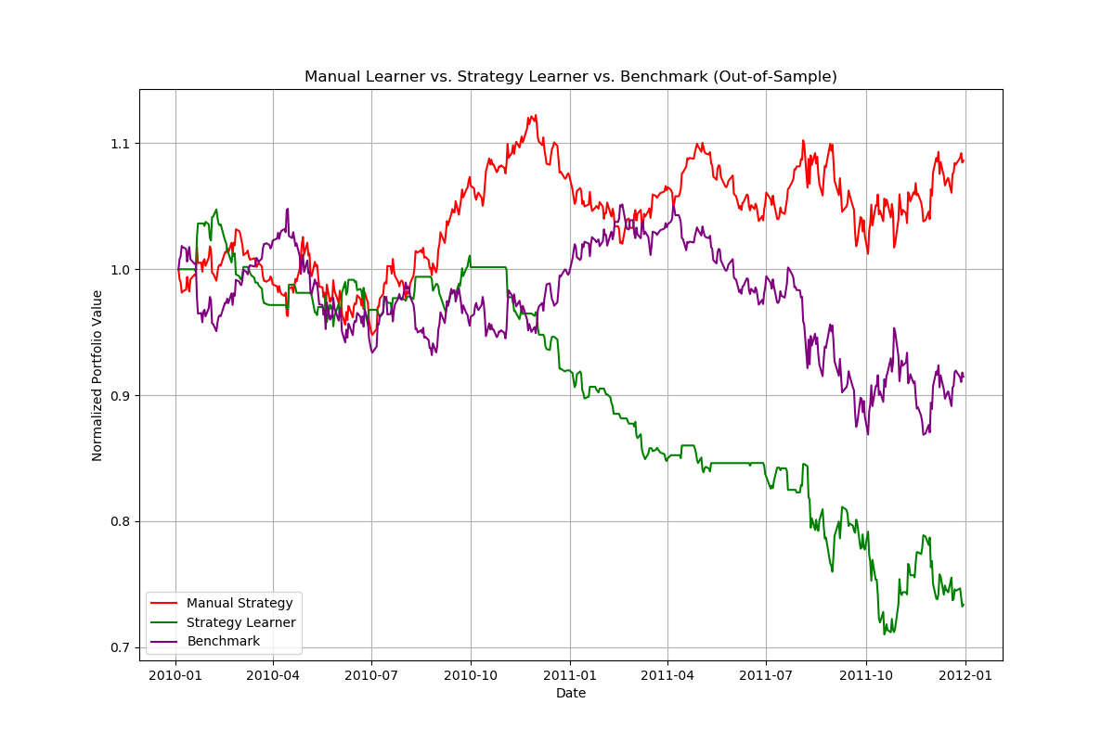

1. Strategy Learner vs Manual Strategy vs Benchmark with normalized portfolio value (out-of-sample)

Table 2 — Performance Metrics Comparison for Manual strategy, Strategy Learner, and Benchmark (in-sample)

|  |  |  |  |
| --- | --- | --- | --- |
| **Period** | **In-Sample** | | |
| **Strategy** | Manual | Strategy Learner | Benchmark |
| **Cumulative Return** | 0.272813 | 1.5145325 | 0.01023621 |
| **Average Daily Return** | 0.00056174 | 0.00186708 | 0.00016466 |
| **Std Daily Return** | 0.01291924 | 0.00850202 | 0.01704123 |
| **Sharpe Ratio** | 0.6902391 | 3.4861149 | 0.15338669 |
| **Final Portfolio Value** | 127281.3 | 251453.25 | 101023.621 |

Table 3 — Performance Metrics Comparison for Manual strategy, Strategy Learner, and Benchmark (out-of-sample)

|  |  |  |  |
| --- | --- | --- | --- |
| **Period** | **Out-of-Sample** | | |
| **Strategy** | Manual | Strategy Learner | Benchmark |
| **Cumulative Return** | 0.08620875 | -0.2662065 | -0.0853088 |
| **Average Daily Return** | 0.00019385 | -0.0005863 | -0.0001412 |
| **Std Daily Return** | 0.00768295 | 0.00760149 | 0.00850128 |
| **Sharpe Ratio** | 0.40053326 | -1.2244045 | -0.2636172 |
| **Final Portfolio Value** | 108388.1 | 73379.35 | 91469.1183 |

To sum up, the performance results during the in-sample period show that the strategy learner significantly outperformed both the manual strategy and benchmark, with a cumulative return of 151.45%, an average daily return of 0.19%, and a Sharpe ratio of 3.49. However, during the out-of-sample period, the strategy learner underperformed, posting a negative cumulative return of -26.62%, an average daily return of -0.06%, and a Sharpe ratio of -1.22. In contrast, the manual strategy performed better during the out-of-sample period, with an 8.62% cumulative return, 0.02% average daily return, and 0.40 Sharpe ratio. These results shows that the strategy learner may have overfit the in-sample data, which caused poor performance during out-of-sample period.

# EXPERIEMENT 2

The experiment 2 is to see the effect on different impact values may affect the strategy learner’s performance during in-sample period. We expected that as the impact value increases, the performance metrics will generally decrease because the impact value may affect the threshold we set for strategy learner to learn and perform trades. We used different impact values of 0.00, 0.01, 0.02, and 0.03, and commission is set to 0 and we use stock "JPM" with in-sample data from January 1, 2008, to December 31, 2009. The seed was set to 903326976 to reproduce the same experimental result. As we can see from figure 5 below, as the impact value increase normalized portfolio value decreases.

1. Different impact values on Strategy Learner (in-sample)

Table 4 — Performance metrics comparison for Strategy Learner on different impact values

|  |  |  |  |  |
| --- | --- | --- | --- | --- |
| Impact | **0** | **0.01** | **0.02** | **0.03** |
| **Cumulative Return** | 2.2255 | 1.411326 | 0.534482 | 0.194402 |
| **Average Daily Return** | 0.0023598 | 0.0017799 | 0.00089613 | 0.00040061 |
| **Standard Deviation of Daily Returns** | 0.00821577 | 0.0080394 | 0.00966192 | 0.00987853 |
| **Sharpe Ratio** | 4.55960923 | 3.51457377 | 1.47233157 | 0.64376277 |
| **Final Portfolio Value** | 322550 | 241132.6 | 153448.2 | 119440.2 |
| **Trade Count** | 224 | 199 | 164 | 127 |

The results showed that as the impact value increases, the performance decreases. For example, the cumulative return decreases from 2.2255 at 0.00 impact to 0.1944 at 0.03 impact. Similarly, the average daily return decreases from 0.236% at 0.00 impact to 0.040% at 0.03 impact. The Sharpe ratio also follows a decreasing pattern, dropping from 4.56 at 0.00 impact to 0.64 at 0.03 impact. The final portfolio value and trade count also decreases with increasing impact values. The result is expected as the impact values increase, the trading threshold will increase and thus fewer trades are made and which may cause undesired learning experience as the learner may think it the best policy is to hold and which lead to poor performance in the in-sample period.